Touchstone 4: Organization Analysis & Strategic Recommendations
SCENARIO: Select an organization you are familiar with or have worked for (currently or in the past). You are tasked with analyzing the organization both internally and externally using some of the tools and frameworks you have learned in this course. You are also tasked with recommending changes to the organization’s strategy and structure, in addition to considering associated ethical implications. This assignment requires you to apply SWOT analysis, PESTEL analysis, Porter’s Five Forces of Industry Analysis, Porter’s Generic Strategies, and organization design concepts related to strategy-structure fit. You will prepare a slide deck containing your analysis and recommendations that could be presented to the organization’s Board.

ASSIGNMENT: Your presentation will be 11-14 slides long, not including the title and references slides. It must include the following slides:
Title
Executive Summary
Organization Background
Internal Strengths
Internal Weaknesses
External Opportunities
External Threats
Macro Environment Analysis: PESTEL
Micro Industry Analysis: Porter’s Five Forces
Generic Strategy Recommendations
Organization Design Recommendations
Ethical Considerations
References
If you’ve never used a presentation tool like PowerPoint or Google Slides before, don’t worry! The assignment template below will help you create slides for a basic slide presentation. Then you’ll be able to practice using the presentation technology as you put the finishing touches on your presentation.

Touchstone 4 Template
Touchstone 4 Sample

Before you get started, let’s look at how you’ll be building the presentation, step by step.
A. Directions
Step 1: Choose an Organization
Select an organization (for-profit or non-profit) that you are familiar with. It is especially important that you understand some of the inner workings of the organization; hence, you may find it easier to select a current or former employer.

Step 2: Create Presentation Slides
Use a presentation tool like PowerPoint or Google Slides to outline and organize your presentation. Your presentation must include the following:

Slide Component
Title Slide Your title slide will be the first slide and should include your name, the date, and the name of the organization you selected.
Executive Summary An executive summary should include the main points of your presentation in 1-2 slides (no more than 2). It should also include your recommendations in 1-3 bullet points. As a general rule, it is usually best (and easiest) to write the executive summary last—after the rest of your presentation is completed.
Organization Background The organization background should be brief—no more than 1-2 slides. It should include a brief history of the organization, in addition to the major products or services offered and the markets that are served. Other possible categories include the founding date, mission statement, annual profits, sales regions, etc.
Internal Strengths Using what you have learned about SWOT analysis, identify 4-6 strengths internally within the organization. You may have to make some inferences based on what you know or perceive about the organization.
Internal Weaknesses Using what you have learned about SWOT analysis, identify 4-6 weaknesses internally within the organization. You may have to make some inferences based on what you know or perceive about the organization.
External Opportunities Using what you have learned about SWOT analysis, list 4-6 opportunities facing the organization externally. Opportunities and threats are generally easier to identify than internal strengths and weaknesses, and are typically shared across the same industry.
External Threats Using what you have learned about SWOT analysis, list 4-6 threats facing the organization externally. Opportunities and threats are generally easier to identify than internal strengths and weaknesses, and are typically shared across the same industry.

Macro Environment Analysis: PESTEL Applying the PESTEL framework to the organization, identify 1-3 factors for each of the following: Political Factors, Economic Factors, Sociocultural Factors, Technological Factors, Environmental Factors, Legal Factors.
Micro Industry Analysis: Porter’s Five Forces Analyze the industry the organization competes in by applying what you have learned about Porter’s Five Forces of industry analysis. You should list 2-3 observations for each of the following factors: Threat of New Entrants, Threat of Substitutes, Supplier Power, Buyer Power, and Industry Rivalry.
Generic Strategy Recommendations Given what you have learned from your internal and external analysis of the organization, are they pursuing the right strategy? If so, why? If not, what might you recommend? Is the recommended (or current) strategy the right “fit” for the environment in which the organization competes? Be sure to select one of Porter’s three generic strategies and provide your rationale: Cost Leadership, Differentiation, or Focus.
Organization Design Recommendations Is the organization optimally designed (structured) for either your recommended or their current strategy? For example, if they are pursuing a Cost Leadership strategy, do they have a low-cost operating model? The objective here is to determine and demonstrate the degree of “fit” between strategy and structure.
Ethical Considerations What are some of the ethical considerations for your recommended (or current) strategy? Is the organization positioned for long-term sustainability? Are there issues which may ultimately affect the organization’s ability to attract and retain talented employees or maintain the credibility of their brand? Are there potential ethical dilemmas in executing any recommended changes? The need to potentially layoff thousands of workers or stop paying for benefits such as healthcare to lower operating expenses, for example?
References This touchstone requires you to use at least four sources, including the course tutorials. Ideas for outside sources include (but are not limited to) organization websites, annual reports, or news articles from reputable magazines or newspapers. Following APA formatting, your sources should appear in alphabetical order.
Step 3: Add Speaker Notes
For this assignment, you are not actually giving a presentation, but rather just preparing a slide deck that summarizes your findings and recommendations.

An important step in the preparation of a speech is writing speaker notes. Speaker notes are notes added to a slide presentation as a reference for the presenter and can be found below each slide. For this touchstone, add your speaker notes to explain your analysis using information from your sources. If you were giving an oral presentation, these notes wouldn't be visible to your audience when you’re in Presenter View. But you would be able to see them, and they would guide you through your presentation.
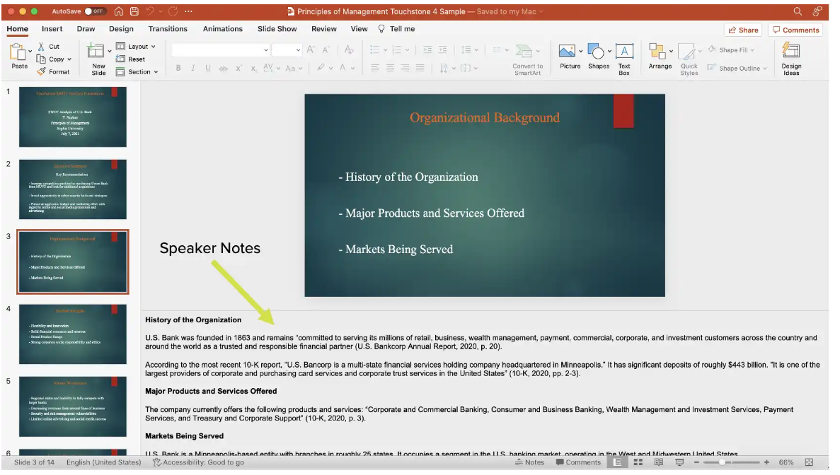
Sample Speaker Notes

Your speaker notes will be used to evaluate your project, so make sure you write in complete sentences and pay attention to spelling and grammar. Also, make sure you’re citing the information from your sources using in-text citations in APA style. These citations should include the author's last name and the year of publication for the source, for example, (Mitchell, 2014).

Most presentation software will automatically display a field for speaker notes. If using Keynote, you can access the speaker notes by clicking on View, then Show Presenter Notes.

Step 4: Submit Presentation
Once you have completed your slides and corresponding speaker notes, it is time to submit your presentation. If you are using PowerPoint, you simply need to save your presentation and upload this file to Sophia. If you are using another slide presentation technology, download the slide deck as a Microsoft PowerPoint (.pptx) and upload this version to Sophia.
C. Requirements
The following requirements must be met for your submission:

All content must be appropriate for an academic context.
Composition must be original and written for this assignment.
Reference slide must include at least four sources.
Presentation must include speaker notes for every slide.
Plagiarism of any kind is strictly prohibited.
Submission must include your name and the date.
File format must be .pptx.

